1. Let’s understand the code in the previous example.
2. Every file in angular contains one simple thing (task) for our application.
3. There are 4 files, we’re going to discuss.
   1. **Component Template**: Contains HTML that gets displayed to a user.
   2. **Component Class:** Containing code to run when important events occur.
   3. **Service:** Contains code that **stores/fetches/updates** data or **business logic** related to our application.
   4. **Module:** Defines a set of components and/or services that are going to exist inside of our application.
4. 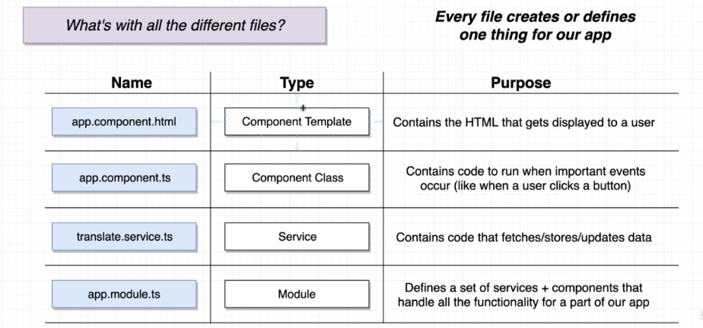

Let’s see now how these four files work together.

1. One-to-one mapping b/w **component template and component class**.
2. There may be 0, 1, 2, or however many different types of **services** depending on types of data we’re try to work with inside our application.
3. **A component template, component class and service** are contained inside a **module**.
4. An app may contain multiple modules each for a major feature.  
   For example: E-commerce app  
   One module for listing products  
   One module for shopping cart  
   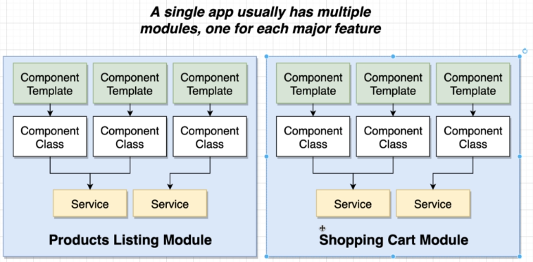
5. There is one more file we didn’t discussed 🡺 **app.component.css** 🡸 We will talk about it later.
6. 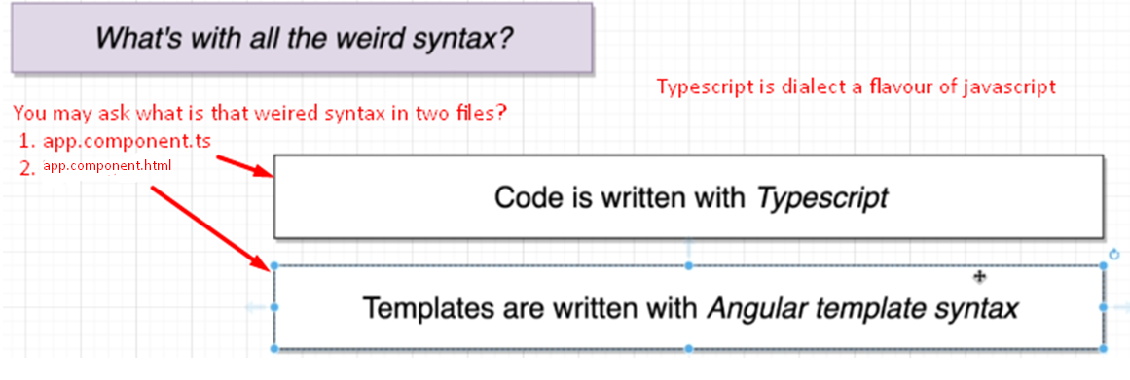
7. 